ENGINEERING COMMISSIONING GUIDE
Plant System Integration
and ModbusLogic Testing
Architecture, workflow order, I/O assignment, activation safety, Control Quality Monitor, migration, and three reference plants
Phase 7 final edition | July 2026 | Schema 8
Purpose Use this guide in order. Define the Live System first, compose a draft with Configure Plant, compile and review the exact immutable plan, activate it explicitly, start communications, run a controlled test, and preserve portable evidence for support.
For simulator preparation, controller integration, factory acceptance, field support, and migration review

1. Architecture and workflow order
One portable plant project owns one topology, one composed signal program, one compiled runtime plan, one set of physical bindings, and one monitor definition.
Architecture in one sentence Live System defines which devices exist; Configure Plant assigns their engineering relationships and logical I/O roles; the composer creates a draft module graph; Compile creates an immutable candidate; Review / Activate is the only boundary that can replace the running plan; Plant Test and Control Quality Monitor then challenge and measure that active plan.
Layer | Authority | What it owns
Live System | Device configuration | I/O-module instances, compressor count, stable device IDs, model, refrigerant, behavior source, connection and Unit ID.
Portable project | .modbussim | Topology, physical bindings, composed plant program, compatible graph, monitor ranges, endpoint selections, ownership, and safety metadata.
Logic View | Plant program navigation | Plant Overview plus Water System, Alarm Outputs, Circuits, per-compressor economizers, and Protocol Adapters.
Compiler | Current editable draft | Validation, namespace flattening, logical and physical output ownership, deterministic order, revision, and runtime signature.
Active runtime | Reviewed compiled plan | One immutable executable image. Draft editing, saving, and migration do not change it.
Plant Test / Monitor | .modbustest and monitor definition | Stimuli, phases, criteria, evidence, normalized trends, quality transitions, and timing metrics.

The required commissioning sequence
Step | Commissioning action
1 | Keep external controller communication stopped. In Live System, create every required I/O-module instance and compressor; set unique connections and Unit IDs.
2 | Set compressor count, model, refrigerant, and behavior mode. Identical compressors should resolve the same selected-model behavior policy.
3 | Confirm physical I/O availability and reserve channels. Do not assign the same writable physical point to two logical outputs.
4 | Open System Integration > Signal Logic and start Configure Plant only after the Live System inventory is correct.
5 | Select circuits, assign every compressor to one circuit, install circuit economizer A/B types, and configure Water Confirmation, alarms, I/O roles, and protocol adapters.
6 | For a heat-exchanger economizer, open the per-compressor section and assign unique stepper, optional solenoid, pressure, temperature, superheat, and optional delayed proof points.
7 | Select Apply topology. This regenerates only the editable draft. Inspect Plant Overview and each detailed module canvas.
8 | Detach a wizard-managed module before custom graph editing that must survive the next topology regeneration. Save a draft checkpoint.
9 | Select Compile. Resolve every error and review the compiled revision, graph fingerprint, output ownership, and diagnostics.
10 | Select Review / Activate. The package is revalidated; only the reviewed current revision can atomically replace the active plan.
11 | Select Run. Start or restart the simulator I/O and compressor Modbus endpoints when their settings changed, then allow the external controller/client to connect.
12 | Verify point quality and direction, perform a manual proof test, load and validate the matching .modbustest plan, then run the controlled test.
13 | Review Signal Logic, Control Quality Monitor, acceptance results, and evidence. Save the final .modbussim and assemble the support packet.

Important order rule The Configuration wizard does not require live Modbus communication. It requires a correct Live System inventory. Configure and compile offline; start communications after the intended plan is active and endpoint/Unit-ID collisions have been eliminated.
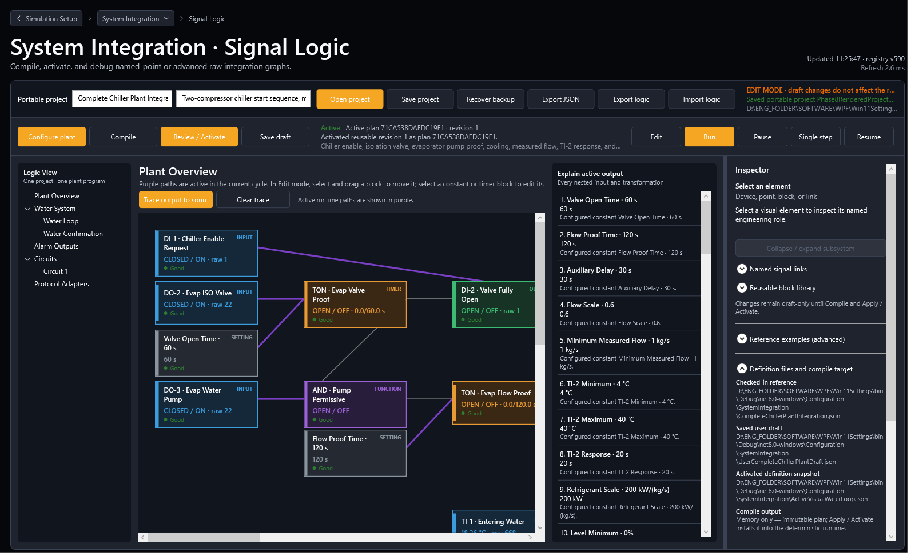
Figure 1. Signal Logic presents one plant program. Logic View opens the overview or a configured module; it does not select competing plant programs.

2. Prepare Live System before Configure Plant
Configure Plant reads equipment identity from Live System. Correct the source inventory first; do not repair device identity only inside the plant wizard.

I/O modules
- Create every I/O-module instance needed by the physical channel count. Phase 7 supports logical role assignment across multiple instances.
- Choose the correct I/O-module type and stable device name. Reserve a unique Unit ID for each module on a shared Modbus connection.
- Record TCP host/port or serial settings, but keep the external controller disconnected until the complete endpoint map has been checked.
- Confirm every required point exists: controller-command DO/AO points consumed by the graph and simulated-field DI/AI/TI points published by the graph.

Compressors
- Set the number of compressors first (one through eight). Configure Plant uses this exact count.
- For each compressor set model, refrigerant, stable identity, connection, Unit ID, and behavior source mode.
- When several compressors have the same model, refrigerant, family, and variant, Selected Model behavior should resolve identically for all of them. A Global Fallback row indicates the source setting or behavior table still differs.
- Compressor-to-circuit assignment is a plant relationship and is set later in Configure Plant; compressor identity is a Live System setting.
Checkpoint | Ready condition | If not ready
Device inventory | Correct I/O count and compressor count. | Return to Live System; do not open the wizard with a known stale count.
Identity | Model, refrigerant, behavior mode, connection, and Unit ID are explicit. | Correct the source row and use Sync from Live System.
Endpoint uniqueness | No duplicated TCP listen endpoint or serial ownership; Unit IDs are unique per bus. | Leave communication stopped and correct the map.
Physical capacity | Enough compatible DI/DO/AI/AO/TI channels exist for the intended roles. | Add another I/O module or disable optional publications.

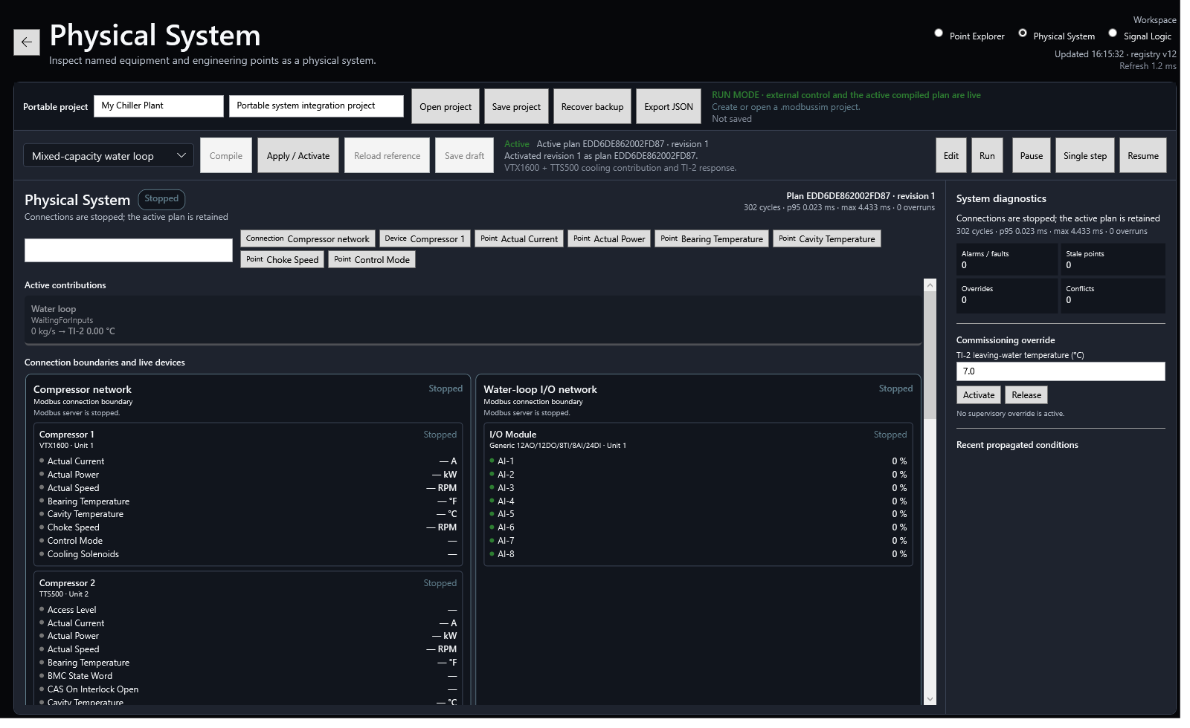
Figure 2. Physical Integration exposes the device and point foundation used by named logical roles.

3. Configure Plant and the Logic View
The wizard composes one plant program from repeated compressor, circuit, water, alarm, economizer, and protocol-adapter modules.

When the wizard can start
Start Configure Plant after the Live System source shows the intended compressor count and identity and after the I/O-module instances exist. Communication may remain stopped. Select Sync from Live System whenever the source inventory changed after the wizard was opened.

Topology decisions
Decision | Rule
Circuits | Select one through eight. Assign every compressor to exactly one circuit.
Economizer slots | Each circuit may install A, B, both, or neither. A compressor may be assigned only to an installed slot in its circuit.
Flash tank | Shared circuit equipment. One vessel model uses the summed mass flow of compressors assigned to that circuit/slot.
Heat exchanger | Per-compressor equipment. Circuit A/B establishes the economizer type and default engineering values; each assigned compressor receives its own instance, mass flow, I/O, and control.
Water Confirmation | Independent of Pump Enable. Select Disabled, Digital switch, Analog flow, or Combined proof.
Pump Enable | Optional. Enable it only when the simulated I/O must receive the external controller's pump command.
Alarm Output | Optional aggregate output with explicit output ownership.
Protocol adapter | Optional read-only raw register/bit decoding into a stable logical input role. Advanced raw output writes remain outside the wizard.

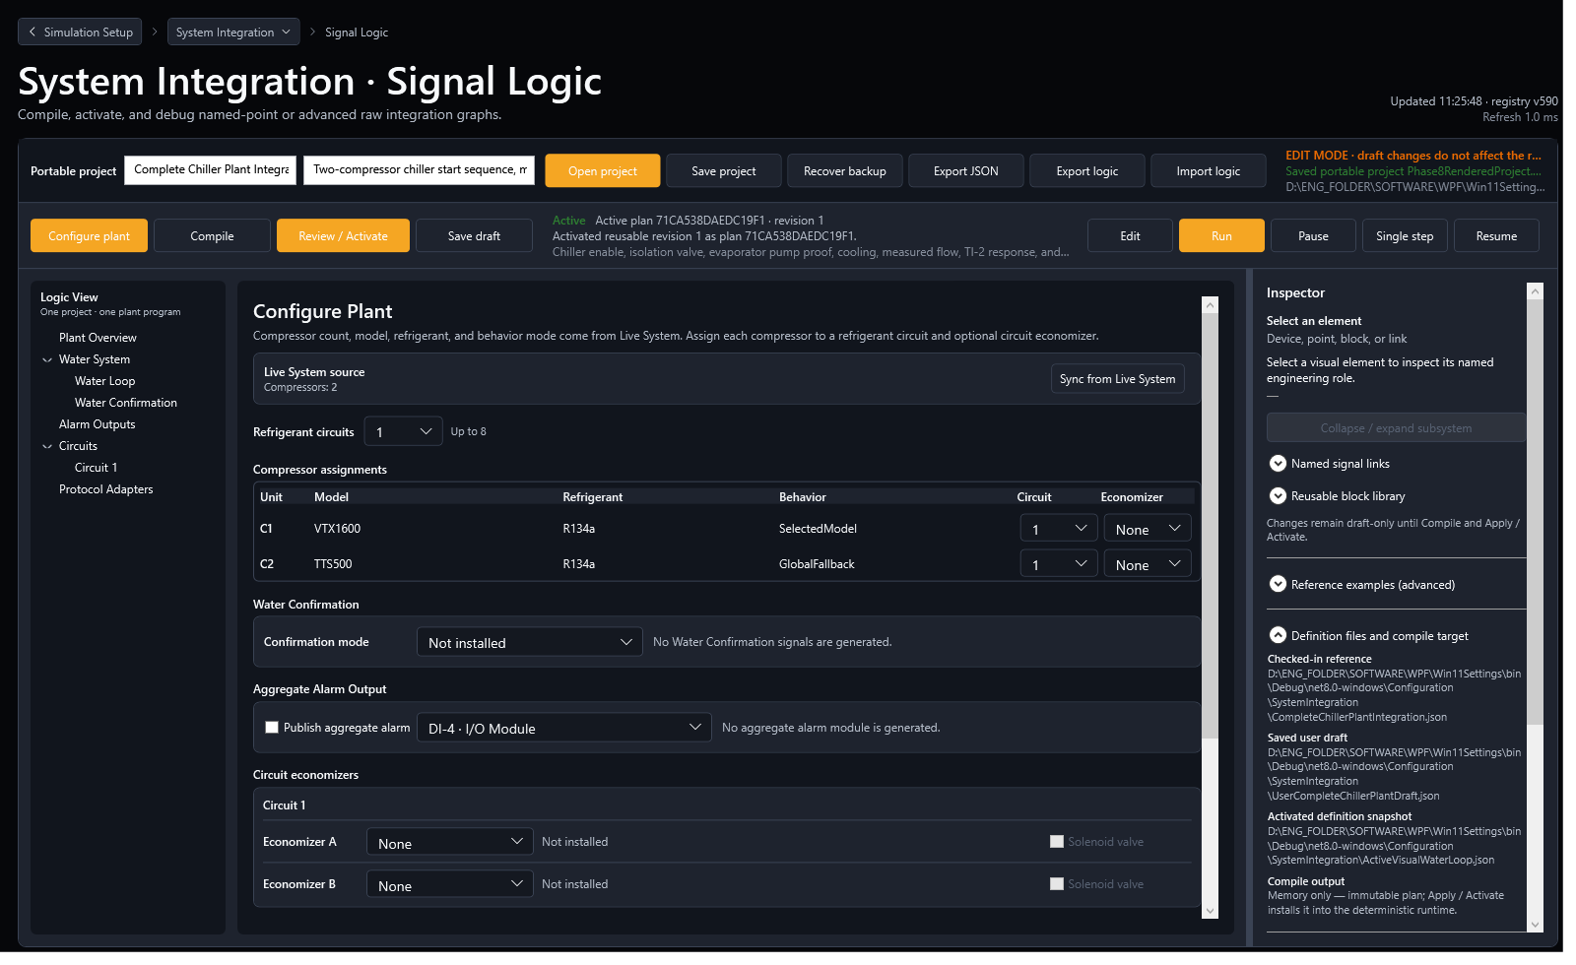
Figure 3. Configure Plant is preloaded from Live System, then adds circuits, economizers, and logical assignments.

Logic View navigation
- Plant Overview shows the composed system and cross-module connections.
- Water System contains the common Water Loop and Water Confirmation modules.
- Circuits lists only configured circuits and installed economizers.
- A flash tank appears once under its circuit slot. A heat-exchanger economizer appears once for every assigned compressor, for example C2 - Heat Exchanger 1A.
- Protocol Adapters shows raw input decoding before downstream logical roles consume the value.

4. Assign physical I/O to logical plant values
A logical role describes engineering meaning. A physical point supplies or receives the raw Modbus value. The binding keeps the plant logic independent from the selected channel and I/O-module instance.
Direction is from the I/O module's perspective A DO or AO is normally written by the external controller and read as an INPUT by the integration graph. A DI, AI, or TI is normally written by the integration graph to simulate field feedback for the external controller.
Logical value | Typical physical point | Graph direction | Example
Plant enable request | DI | Plant Test/operator -> simulated I/O -> graph input | Plant.EnableRequest -> Module 1 DI-1
Pump command | DO | External controller -> simulated I/O -> graph input | Water.PumpCommand -> Module 1 DO-1
Flow switch/proof | DI | Graph output -> external controller input image | Water.FlowSwitch -> Module 1 DI-2
Measured flow | AI | Graph output -> external controller input image | Water.FlowSensor -> Module 2 AI-1
Water ready | DI | Graph output -> external controller input image | Water.Proven -> Module 2 DI-1
Stepper command | AO | External controller -> graph input | Compressor3.Economizer.StepperCommand -> Module 1 AO-3
Solenoid command | DO | External controller -> graph input | Compressor1.Economizer.SolenoidCommand -> Module 1 DO-1
Valve-open proof | DI | Graph TON output -> external controller input image | Compressor1.Economizer.ValveOpenProof -> Module 1 DI-4
Pressure/superheat | AI | Graph engineering conversion -> external controller input image | Compressor2.Economizer.Pressure -> AI-3
Interstage temperature | TI | Graph engineering value -> external controller input image | Compressor2.Economizer.Temperature -> a named TI point

Safe assignment method
- Write an I/O schedule with device stable ID, channel, electrical direction, engineering role, range, and owner.
- Select only a compatible point in Configure Plant. Digital roles cannot use analog points; engineering publications must match the point type and unit conversion.
- Give every writable logical role a unique physical point. The compiler rejects duplicate logical ownership and physical output conflicts.
- For an input decoded from a raw register, configure a Protocol Adapter and publish the decoded typed value to the logical role. Do not duplicate that role with a second named-point source.
- Apply topology and inspect the generated INPUT/OUTPUT nodes. Trace each important output back to the selected physical point before activation.
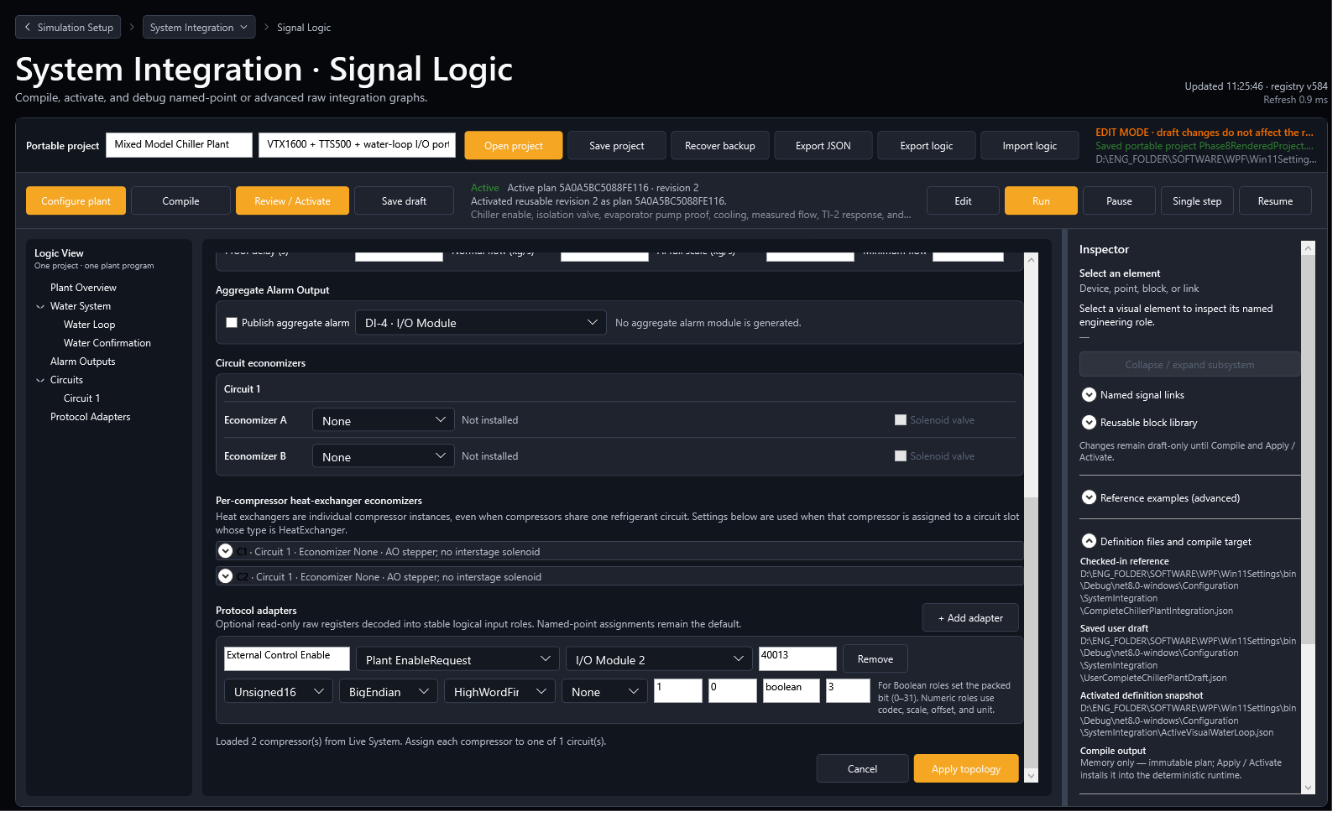
Figure 4. Protocol Adapters turn read-only raw registers and packed bits into named typed roles before plant logic.

5. Water Confirmation wizard
Water Confirmation is a reusable plant module. Pump Enable is optional and does not determine whether water confirmation exists.
Mode | Required source | Proof behavior
Disabled | None | No water proof is generated; use only when the downstream plant does not require it.
Digital | Assigned flow switch/proof DI | The configured digital state must remain true for Proof delay.
Analog Flow | Assigned AI plus full-scale and minimum flow | Raw percent is converted to kg/s and compared with Minimum flow; the result passes through Proof delay.
Combined | Digital proof and analog flow | Both conditions must remain true for Proof delay.

Configuration fields
- Use enable request: maps the plant start stimulus, commonly DI-1 but never hard-coded.
- Use pump enable: reads an external controller pump DO only when the project needs it.
- Digital proof output: simulated DI feedback for switch-style water confirmation.
- Analog flow output: simulated AI feedback. Set Normal flow, analog full scale, and minimum acceptable flow in kg/s.
- Write ready output: publishes the final water-confirmed state on an assigned DI.
- Proof delay: editable continuous-true TON delay. Any required condition becoming false resets elapsed time.
Common plant choice Most machines need water confirmation but do not need a separate Pump Enable input. Select Digital, Analog Flow, or Combined and leave Use pump enable clear unless the controller's pump command is part of the intended proof chain.

6. Economizer configuration
Phase 7 distinguishes circuit-shared flash tanks from compressor-specific heat exchangers and gives every heat-exchanger instance independent I/O.

Flash-tank economizer
- Install Flash Tank in circuit slot A or B. It appears once for that circuit/slot.
- The circuit capacity/mass-flow sum drives the vessel target.
- Assign the valve command, optional level publication, mass-flow coefficient, valve gain, minimum and maximum level, nominal level, and response time.
- Use Control Quality Monitor to compare valve command, level target, measured/simulated level, quality, and time outside the configured level band.

Heat-exchanger economizer - one instance per compressor
- Install Heat Exchanger in circuit slot A or B and assign each applicable compressor to that slot.
- Circuit settings seed engineering defaults, but the per-compressor expander is the authority for unique physical I/O.
- Each instance uses its compressor's cooling contribution to derive refrigerant mass flow. It is not driven by one shared circuit fraction.
- Assign a unique AO stepper command, optional DO solenoid command, optional delayed DI proof, pressure AI, interstage temperature TI, and superheat AI.
- Configure design mass flow, base pressure, pressure gain/relief, base superheat, mass-flow and valve gains, setpoint, stepper response, and full scales.
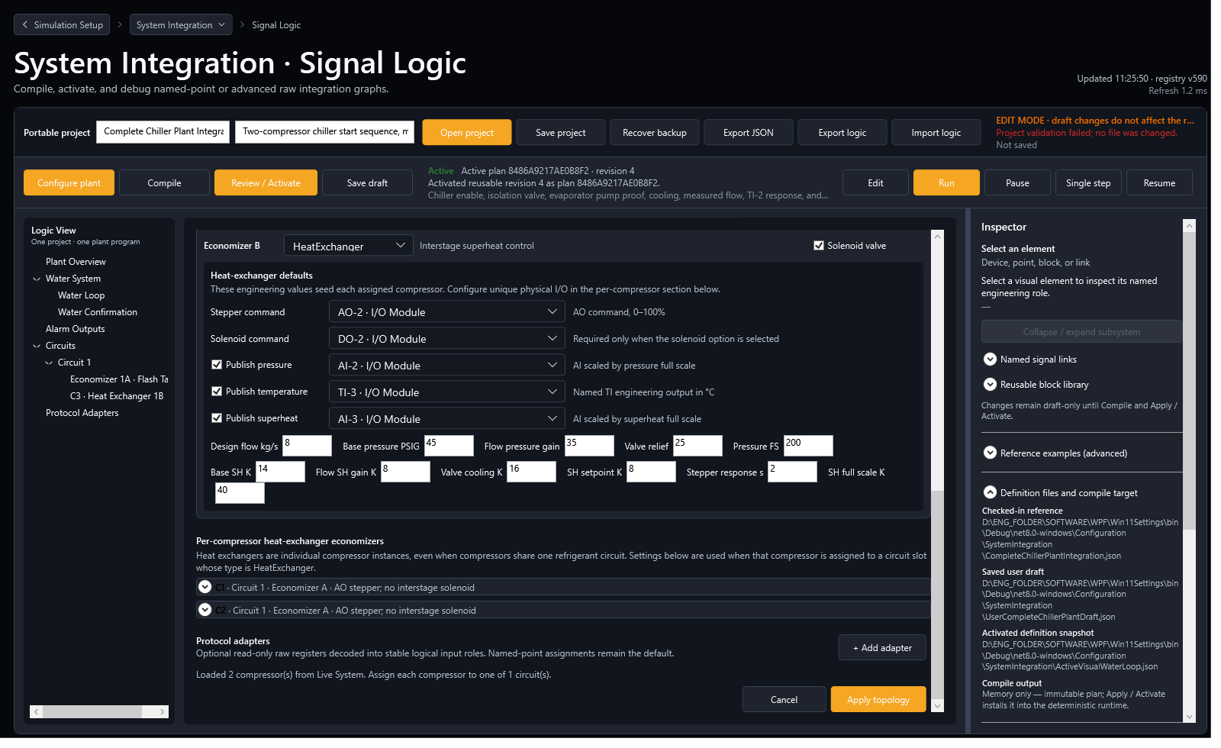
Figure 5. Circuit economizer engineering settings seed assigned compressors; per-compressor sections hold the unique heat-exchanger I/O.
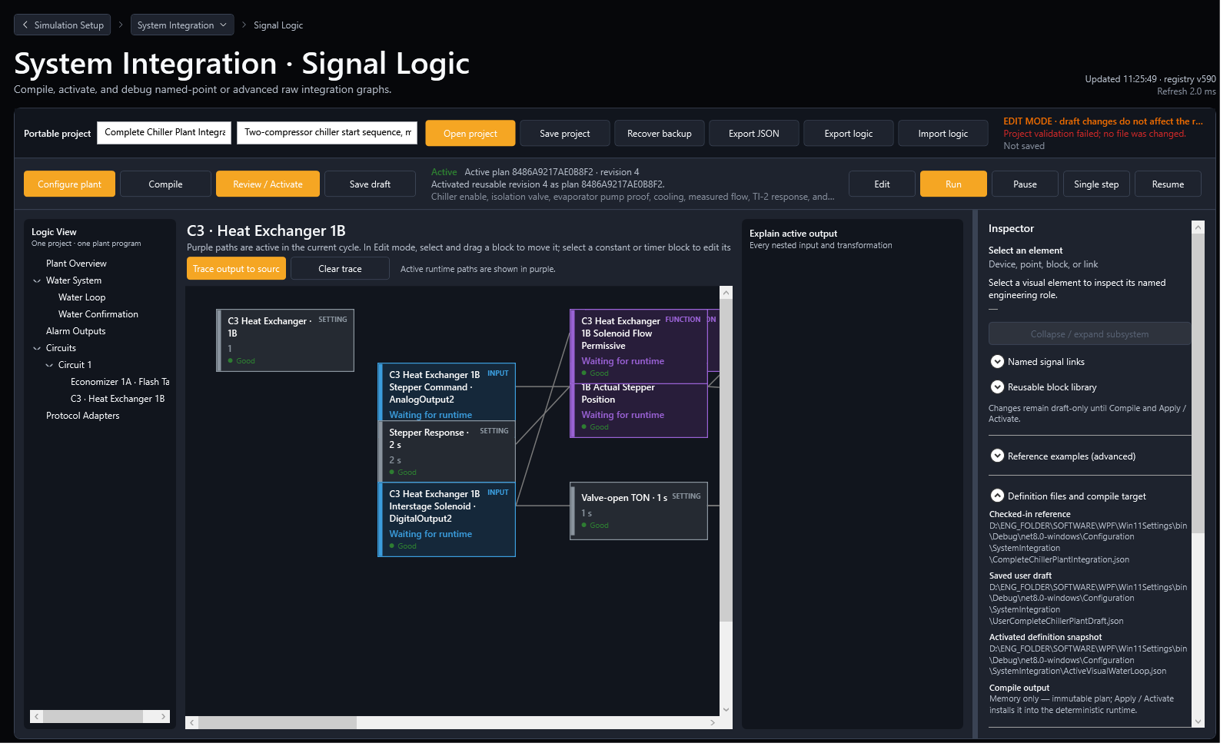
Figure 6. A detailed economizer canvas shows the active transformation path and live engineering values.

Optional solenoid and editable TON valve-open proof
When an auxiliary controller DO energizes the interstage solenoid, select Has solenoid valve and assign its DO command. If the test also needs a simulated auxiliary proof, select Publish valve-open proof, assign a DI, and set Valve-open proof delay. The generated OnDelay block publishes proof only while the solenoid command remains continuously energized for the configured time.
DO solenoid command -> OnDelay Input
Valve-open proof delay (s) -> OnDelay Delay
OnDelay Value -> assigned DI valve-open proof
Command opens before delay: elapsed resets to 0
Command remains closed for delay: proof becomes true
Command opens after proof: proof resets immediately
Physical switch alternative The generated TON models actuator travel for testing. If the project must use a real auxiliary switch/register instead, bind that measured value through a named point or read-only Protocol Adapter and do not also publish the simulated proof to the same role.

7. Edit, compile, review, activate, and run
Lifecycle state is intentionally explicit. Editing speed comes from the wizard and module views; runtime safety comes from keeping draft work separate from the active plan.
Action | Result | Active runtime
Apply topology | Regenerates wizard-managed modules in the editable draft; preserves detached modules. | Unchanged
Edit / Import logic | Changes node values, wiring, comments, layout, or a text-logic draft. | Unchanged
Save draft | Stores a local draft checkpoint. | Unchanged
Compile | Validates topology, roles, ownership, graph, ports, units, cycles, and creates an immutable candidate revision/signature. | Unchanged
Save project | Atomically writes the portable .modbussim plus recovery backup handling. | Unchanged
Review / Activate | Revalidates package, revision, fingerprint, endpoints, and claims; atomically installs the candidate. | Replaced only on success
Run | Executes the active plan on deterministic cycle boundaries. | Same active signature

What to do after editing
- Save a draft checkpoint and visually inspect every edited module.
- Trace safety-critical outputs to their sources and verify timer constants, units, polarity, reset behavior, and selected points.
- Compile. Treat every error as blocking; review warnings against the intended test.
- Compare the compiled revision and signature with the change record. Confirm the expected output claims and no unexpected raw writes.
- Select Review / Activate. If the draft changed after compile or the portable graph changed after review, activation is rejected.
- Run a short dry test before starting the complete automated plan. Save the approved portable project only after the behavior is accepted.

8. Phase 7 activation safety and migration
Safety metadata makes the reviewed compiled graph tamper-evident and preserves the previously active plan across failed validation or legacy migration.
Control | Phase 7 rule
Activation fingerprint | SHA-256 is computed from the deterministic graph content stored with the portable project.
Revision lock | Expected graph revision must equal the current compiled revision at activation.
Immediate revalidation | The complete package is validated again at Review / Activate, not only when opened.
Failure behavior | The prior active signature, plan, and output ownership remain installed.
Migration behavior | Older packages receive safety metadata as a draft-only migration; the runtime is not changed.
Legacy graph | A schema-8 single graph opens as a behavior-preserving legacy-main module.
Legacy heat exchanger | Circuit-level heat-exchanger settings seed per-compressor draft instances; the original compiled compatibility graph remains unchanged until Apply topology.
Atomic save | An interrupted primary save retains the last valid project; Recover backup uses the validated backup.

Migration review procedure
- Make a versioned copy of the original .modbussim and its .bak before opening it in a newer application build.
- Open the project. Read every migration diagnostic. Confirm that the current active plan did not change.
- If the project is wrapped as legacy-main, first verify behavior with the preserved graph. Use Configure Plant only when the project is ready to adopt module composition.
- For legacy heat exchangers, inspect each seeded per-compressor instance and assign unique physical points before applying topology.
- Compile, compare topology and output claims, run the matching regression test, and activate only after review.
- Save under a new revisioned file name; retain the original and backup until customer acceptance is complete.
Activation rejection is a safe result Fingerprint mismatch, compiled-revision change, invalid ownership, unsafe raw output, unsupported template revision, or invalid topology must leave the previous plan running. Correct the draft and compile again; do not attempt to bypass the boundary.

9. Start communication safely
Communication is a separate operational boundary from compiling and activating the plant plan.

Recommended start order
- With communications stopped, verify TCP/serial settings and unique Unit IDs for all I/O modules and compressors.
- Activate and Run the reviewed integration plan. Confirm no compile/runtime diagnostics and no output-owner conflict.
- Start or restart the simulator I/O endpoint, then the compressor endpoints, when their packaged settings changed.
- Allow the external controller/client to connect. Verify that it reads the intended Unit IDs and that no second process owns the endpoint.
- Observe communications and point quality before applying plant enable. Start with commands in their safe/off state.
- Perform one channel-at-a-time direction checks, then the water-proof handshake, then compressor/economizer response.
Do not start too early Connecting the controller before Unit IDs, endpoint ownership, and physical role assignments are confirmed can make a correct logic graph appear wrong or can drive the wrong simulated channel.

10. Control Quality Monitor plant trends
The monitor is an observational engineering workspace. It samples internal and physical values after deterministic cycles without changing the control graph.
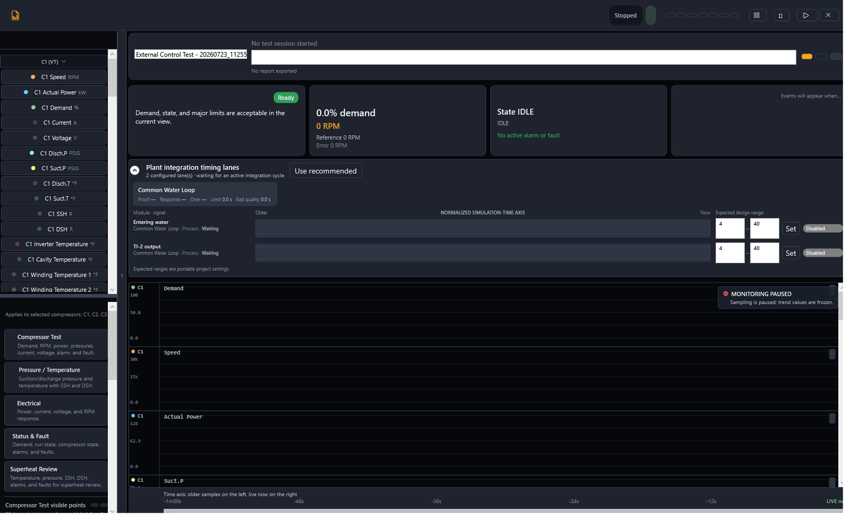
Figure 7. Control Quality Monitor aligns command, proof, process response, and quality on one simulation-time axis.

How to read normalized lanes
Analog values use (value - expected minimum) / (expected maximum - expected minimum). Digital values use discrete bands. This lets signals with different units share one vertical timing diagram without pretending they have the same engineering magnitude.
Trend or metric | Engineering question
Command and proof lanes | Did proof follow command, in the correct order, without chatter?
Command-to-proof delay | How long did the valve, pump, or auxiliary TON take after a stable command?
Response time | How long did level, temperature, pressure, or valve position take to enter the expected band?
Overshoot | How far did the response exceed the target/range during startup or load change?
Time outside limits | How long was the point outside the editable expected range after settling?
Stale/invalid markers | Was a failed trend caused by unavailable data rather than control response?
Per-compressor economizer lanes | Do individual stepper, solenoid/proof, pressure, temperature, and superheat signals match that compressor's mass flow?
Circuit/plant lanes | Do shared flash level and total capacity follow the correct circuit and plant sums?

Expected ranges are not control settings Editing a monitor range changes normalization, recommendations, and evidence only. It does not tune the stepper, flash-tank level, Water Loop, or active runtime. Change control settings in Configure Plant or the editable graph, then compile and activate.

11. Files, locations, extensions, and purpose
Use the portable project as the master handoff. Local draft and activated snapshots are implementation aids, not substitutes for the complete package.
File / extension | Normal location | Purpose
*.modbussim | Configuration/SystemIntegration or customer project folder | Portable plant master: devices, connections, topology, program, graph, roles, monitor, ownership, safety metadata, and layout.
*.modbussim.bak or *.bak | Beside the project | Last validated recoverable save. Keep until the new revision passes testing.
*.modbustest | Configuration/SystemIntegration/Examples or test folder | Test stimuli, phases, mappings, criteria, and evidence policy.
*.modbuslogic | Engineering source/export folder | Readable editable graph exchange. It does not carry the complete portable device/topology package.
*.json reference definitions | Configuration/SystemIntegration | Checked-in templates, compatibility definitions, and internal manifests.
UserVisualWaterLoopDraft.json | bin/<configuration>/<target>/Configuration/SystemIntegration | Local editable draft snapshot. Not the customer handoff.
ActiveVisualWaterLoop.json | bin/<configuration>/<target>/Configuration/SystemIntegration | Local activated definition snapshot used for inspection/recovery. Not the portable master.
*.csv / *.jsonl / result.json / *.md | Plant Test evidence or Reports/SystemIntegration | Samples, events, machine-readable results, readable reports, and validation evidence.
*.png | Reports/SystemIntegration | Automated dark/light-theme or commissioning screenshots used as visual evidence.

Reference examples delivered by Phase 7
- Configuration/SystemIntegration/Examples/WaterCooled_3xVTX1600_R134a_FlashTank1A.modbussim and matching .modbustest
- Configuration/SystemIntegration/Examples/AirCooled_3xVTS350_R134a_PerCompressorHeatExchangers.modbussim and matching .modbustest
- Configuration/SystemIntegration/Examples/AirCooled_4xTTS350_R515B_2Circuits_4HeatExchangers.modbussim and matching .modbustest
Naming rule Use a stable descriptive stem plus a controlled revision, for example Customer_Site_ChillerA_4xTTS350_R515B_v03.modbussim. Keep the matching .modbustest stem/revision in the release record.

12. Prepare, start, and validate a test
A complete test proves mapping, sequence, calculation, timing, recovery, evidence integrity, and the absence of unsafe runtime replacement.
Run gate Do not select Start plant test until the intended portable project is active, the plan preflight passes, communications are Online, critical point quality is Good, and manual channel direction checks are complete.
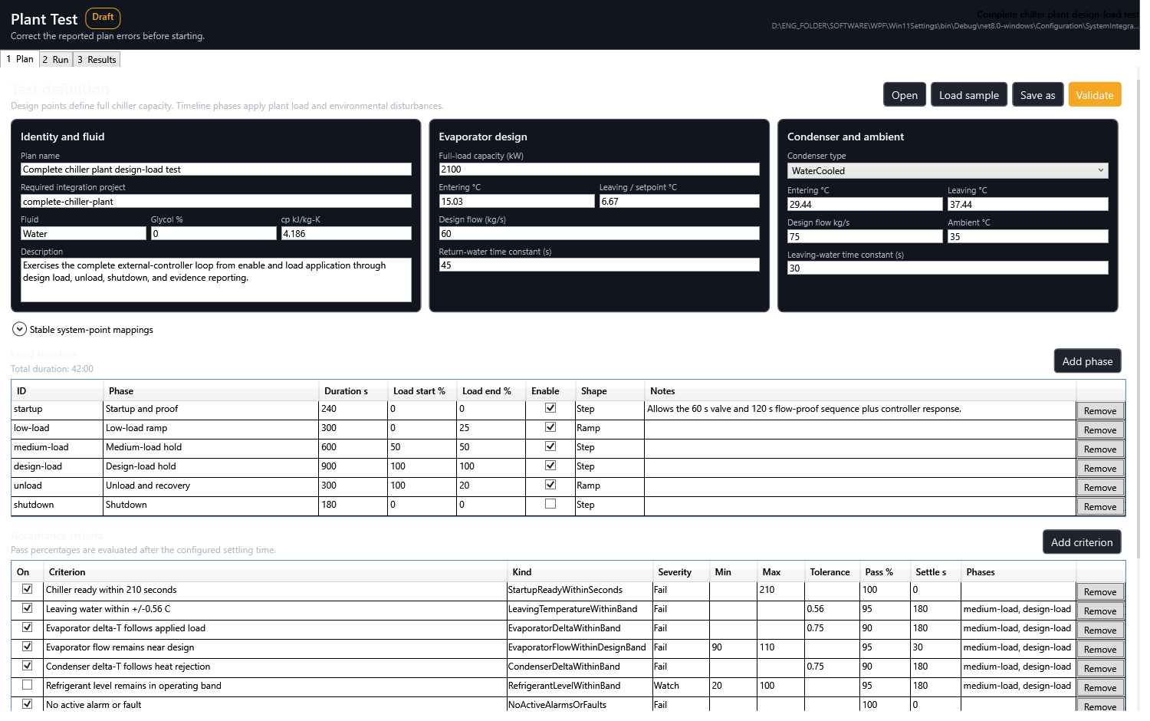
Figure 8. Plant Test separates plan design, active run, acceptance results, and durable evidence.

Prepare
- Use the approved revision of the .modbussim and matching .modbustest.
- Verify compressor identities, circuit/economizer assignments, physical I/O schedule, endpoint map, Unit IDs, rated capacity, flow, temperature design values, delays, and acceptance limits.
- Compile, Review / Activate, and Run. Confirm critical points are Good and communications are Online.
- Validate the test plan. Resolve project/signature mismatch, missing point mapping, ownership conflict, unsupported criterion, and evidence-path errors.
- Begin with commands safe/off; remove commissioning overrides; prevent Windows sleep for unattended tests.

Reference test logic
Phase | Typical stimulus | Primary validation
Startup and proof | Enable true, 0% load | Valve/pump/flow/ready order, TON reset, readiness deadline.
Low-load ramp | 0 -> 25% | First compressor/economizer response, stable flow, no ownership or quality faults.
Medium-load hold | 50% | Capacity sum, circuit mass flow, water-loop response, economizer regulation.
Design-load hold | 100% | Full capacity, leaving-water target, expected level/superheat bands, response time and overshoot.
Unload/recovery | 100 -> 20% | Stable de-loading, no latch/chatter, recovery into bands.
Shutdown | Enable false, 0% | Outputs and proofs reset in the intended order; timers and dynamics return safely.

Manual pre-test before automation
- Toggle one mapped enable input and confirm the logical role changes once.
- Exercise pump/valve/solenoid commands individually and verify the expected DI/AI/TI feedback direction.
- Interrupt a command before its TON expires and verify elapsed time and proof reset.
- Run one compressor at low demand and verify its capacity contribution, assigned circuit sum, and economizer instance.
- Repeat for each compressor and each I/O-module instance before running a multi-compressor phase.
- Introduce one safe proof/flow loss and verify readiness, contribution gating, quality, and report events.

Validate and report
- Review every Fail and Watch criterion with settling time and required pass percentage.
- Correlate Plant Test samples with Signal Logic trace and Control Quality Monitor timing lanes.
- Confirm no failed runtime cycles, unplanned Stale/Invalid intervals, ownership conflicts, or endpoint reconnect loops.
- Retain plan.modbustest, samples.csv, events.jsonl, result.json, readable report, monitor export, application version, controller version, active project signature, and screenshots.
- State deviations explicitly. A test report is high quality only when another engineer can identify the exact project, plan, I/O map, runtime signature, conditions, results, and unresolved limitations.

13. Common order and configuration errors
Most commissioning problems are caused by doing a correct action at the wrong lifecycle stage or assigning the correct engineering role to the wrong physical direction.
Symptom | Likely order error | Correction
Wizard shows old compressor count/model | Live System changed after wizard opened. | Correct Live System, then Sync from Live System before Apply topology.
Identical compressors show different behavior modes | One row uses fallback or a different identity/table source. | Align model, refrigerant, variant, and behavior source in Live System.
Topology returns to two default compressors | An old draft/reference was compiled or the new topology was not applied. | Apply topology, confirm generated compressor modules, then compile the current draft.
Heat-exchanger signals are shared | Only circuit defaults were considered. | Open each per-compressor heat-exchanger expander and assign unique I/O.
Pump logic appears unnecessarily | Use pump enable was selected for a water-proof-only plant. | Clear Use pump enable; retain Digital/Analog/Combined Water Confirmation.
A command reads backwards | DI/DO naming was interpreted from the controller rather than I/O-module perspective. | Recheck INPUT vs OUTPUT direction and physical schedule.
Compile rejects output conflict | Two roles publish the same physical DI/AI/TI or raw output. | Assign a unique point or disable an optional publication.
Apply topology changed canvas but not behavior | Expected behavior: only the draft changed. | Compile, review, activate, then Run.
Saved project but live system is unchanged | Save was mistaken for activation. | Review / Activate the current compiled revision.
Activation rejected after edit | Draft revision/fingerprint changed after compile or review. | Compile again and review the new signature.
Timer never advances | Plan not running, command false/chattering, wrong point, or stale quality. | Trace timer Input/Delay and inspect quality on every prerequisite.
Plant Test will not start | No active matching project/signature, invalid mapping, or stimulus ownership conflict. | Activate the correct plan and rerun test preflight.
Monitor range edit did not tune control | Monitor evidence was mistaken for executable configuration. | Change topology/graph settings, compile, and activate.
Controller connects to wrong device | Communication started before endpoint/Unit-ID review. | Stop clients, correct unique map, restart servers, reconnect in order.

14. Port a plant plan for customer support
A support handoff must reproduce the plant identity, physical bindings, active logic candidate, test conditions, and observed failure without relying on local draft files.

Customer-to-support packet
- Stop the plant test safely and remove enable/commissioning overrides. Record the active project signature and application version.
- Select Save project to a versioned .modbussim file. Keep its .bak.
- Save the exact .modbustest plan used. Export .modbuslogic only when readable graph review or source-level editing is requested.
- Export the Plant Test result/evidence and Control Quality Monitor report; include screenshots of the failing Logic View and physical I/O map.
- Include a plain I/O schedule: device stable ID, model, endpoint, Unit ID, physical channel, logical role, electrical direction, range/unit, normal state, and owner.
- Include controller software version, scenario, expected behavior, actual behavior, first failing timestamp, and steps to reproduce.
- Sanitize customer IP addresses, serial details, names, or other site data when policy requires; do not remove stable device/point identities needed for reproduction.

Support review and return
- Open the received project as a compiled draft. Opening or migration must not replace the support workstation's active plan.
- Review package diagnostics, migration messages, safety fingerprint, connection map, output claims, topology, and per-compressor economizer assignments.
- Run the matching .modbustest against an isolated simulator configuration and compare its evidence with the customer report.
- Return a new revisioned .modbussim and matching .modbustest; do not overwrite the customer's accepted baseline.
- The customer must review local endpoints and physical mappings, compile, activate explicitly, run a dry test, and complete regression before acceptance.
Do not send only ActiveVisualWaterLoop.json That local snapshot is not the complete portable project. The .modbussim file is the support master because it carries device, topology, role, monitor, ownership, layout, compatibility, and activation-safety data.

15. Reference example 1 - water-cooled flash tank
One circuit, three VTX1600 compressors, R134a, and one circuit-shared 1A flash-tank economizer.
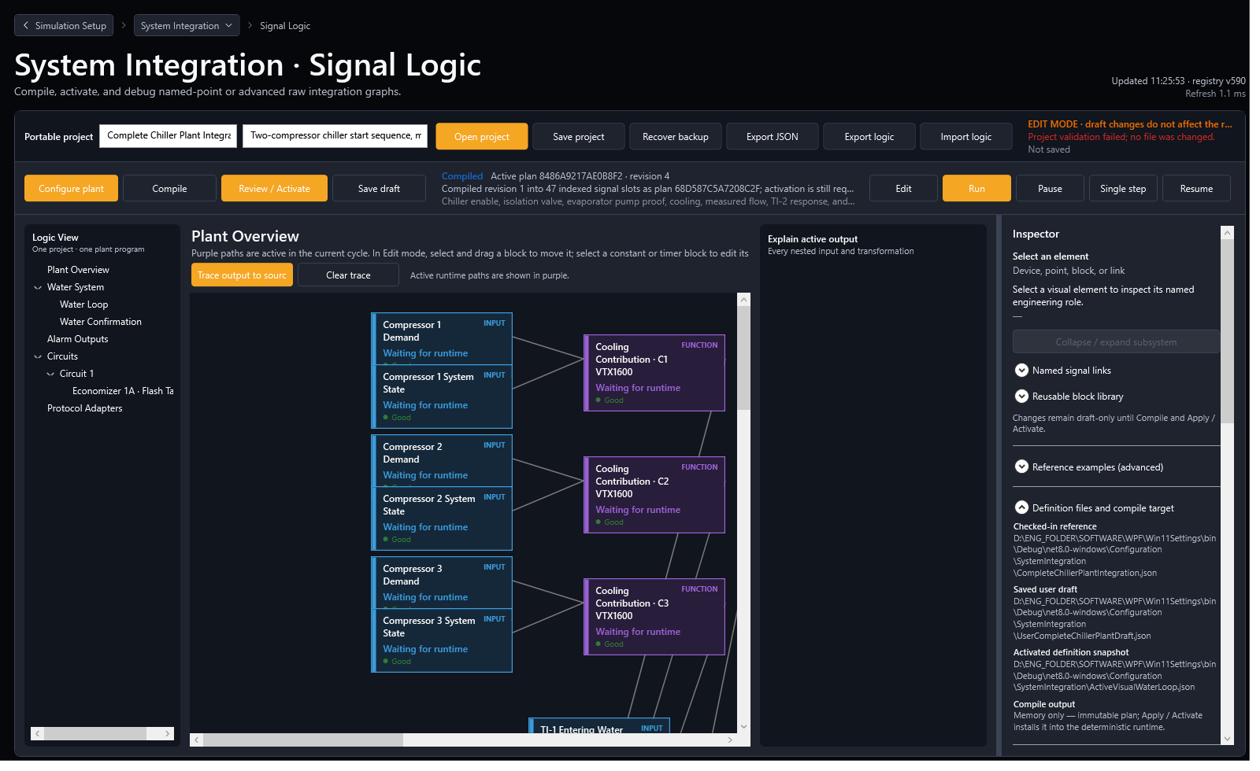
Figure 9. Example 1 Configure Plant view: three VTX1600 compressors share Circuit 1 and Flash Tank 1A.
Item | Reference setting
Portable files | WaterCooled_3xVTX1600_R134a_FlashTank1A.modbussim / .modbustest
Compressors | C1-C3: VTX1600, R134a, Selected Model, Circuit 1, Economizer A
Economizer | Circuit 1A Flash Tank; AO-1 valve command; AI-4 level; design mass flow 24 kg/s; level band 20-80%; response 20 s
Water Confirmation | Combined; enable DI-1; no pump-enable dependency; digital proof DI-2; analog flow AI-1; ready DI-3; proof TON 3 s
Water design | 4,800 kW full load; 138 kg/s evaporator flow; analog full scale 150 kg/s; minimum flow 20 kg/s
Monitor focus | Three contributions -> Circuit 1 sum -> plant sum; flash valve, level target/response, water proof, entering/leaving water.

Example 1 test emphasis
- Prove DI and AI conditions independently, then together; interrupt either before the 3-second TON expires.
- Run each compressor alone and verify the same shared flash tank uses the correct Circuit 1 mass-flow sum.
- Step from low to design load and verify level remains inside the configured band after settling.
- Confirm condenser-water criteria remain enabled in the water-cooled .modbustest plan.

16. Reference example 2 - air-cooled per-compressor heat exchangers
One circuit, three VTS350 compressors, R134a, and one independently assigned heat-exchanger economizer for every compressor.
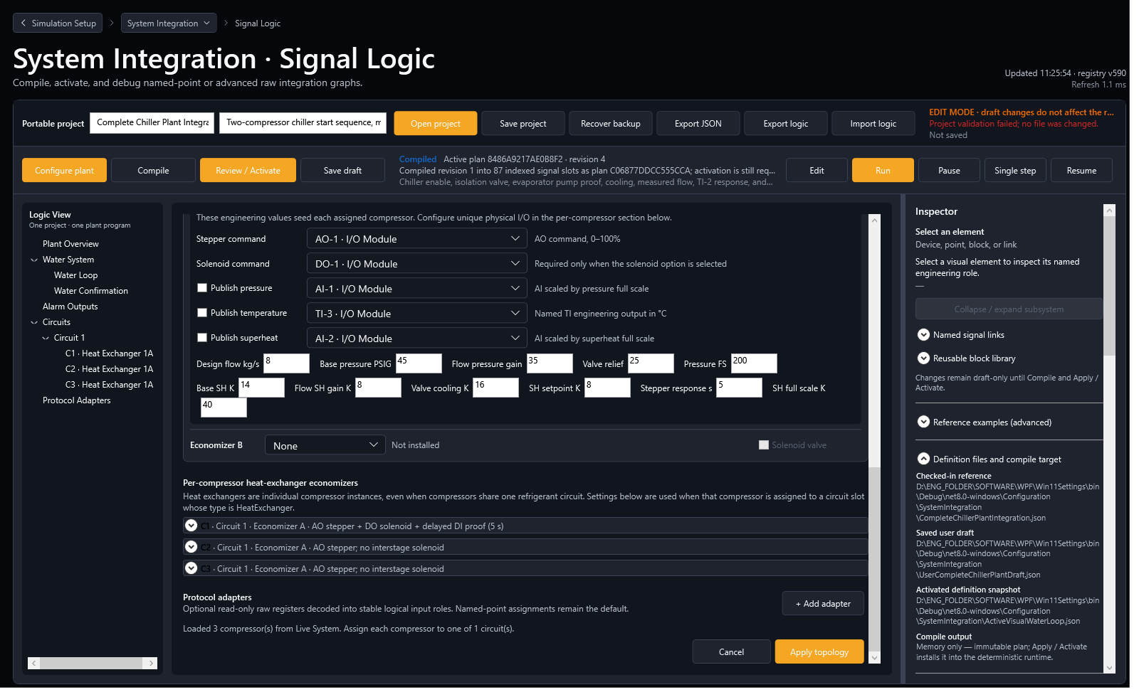
Figure 10. Example 2 shows the per-compressor heat-exchanger section and unique channel assignments.
Compressor | Stepper / optional solenoid | Engineering publications
C1 | AO-1; DO-1 solenoid; DI-4 delayed valve proof, 5 s | Pressure AI-1; named interstage TI; superheat AI-2
C2 | AO-2; no solenoid | Pressure AI-3; named interstage TI; superheat AI-4
C3 | AO-3; no solenoid | Pressure AI-5; named interstage TI; superheat AI-6

Item | Reference setting
Portable files | AirCooled_3xVTS350_R134a_PerCompressorHeatExchangers.modbussim / .modbustest
Topology | C1-C3: VTS350, R134a, Selected Model, Circuit 1, Heat Exchanger 1A
Water Confirmation | Analog Flow; enable DI-1; no pump-enable dependency; flow AI-7; ready DI-3; minimum 5 kg/s; full scale 40 kg/s; TON 2 s
Plant design | 1,050 kW full load; 30 kg/s evaporator flow
Economizer defaults | 5 kg/s design mass flow; 45 psig base pressure; 8 K superheat setpoint; 5 s stepper response

Example 2 test emphasis
- Verify C1 DO-1 must remain energized for 5 seconds before DI-4 proof; interrupt the command to prove reset.
- Run C1, C2, and C3 separately. Only the selected compressor's pressure, temperature, superheat, and stepper trends should respond to its mass flow.
- Run all compressors and confirm outputs remain independent although all compressors share Circuit 1.
- Air-cooled test logic disables condenser-water delta criteria and leaves refrigerant-level criteria disabled because the plant has no flash-tank level point.

17. Reference example 3 - two circuits and four heat exchangers
Air-cooled plant with four TTS350 compressors, R515B, two circuits, four per-compressor heat exchangers, a pump command, and analog water confirmation on a second I/O module.
Circuit split C1/C2 feed Circuit 1; C3/C4 feed Circuit 2. Each compressor keeps its own heat-exchanger I/O, while both circuit sums feed the common plant capacity sum and water loop.
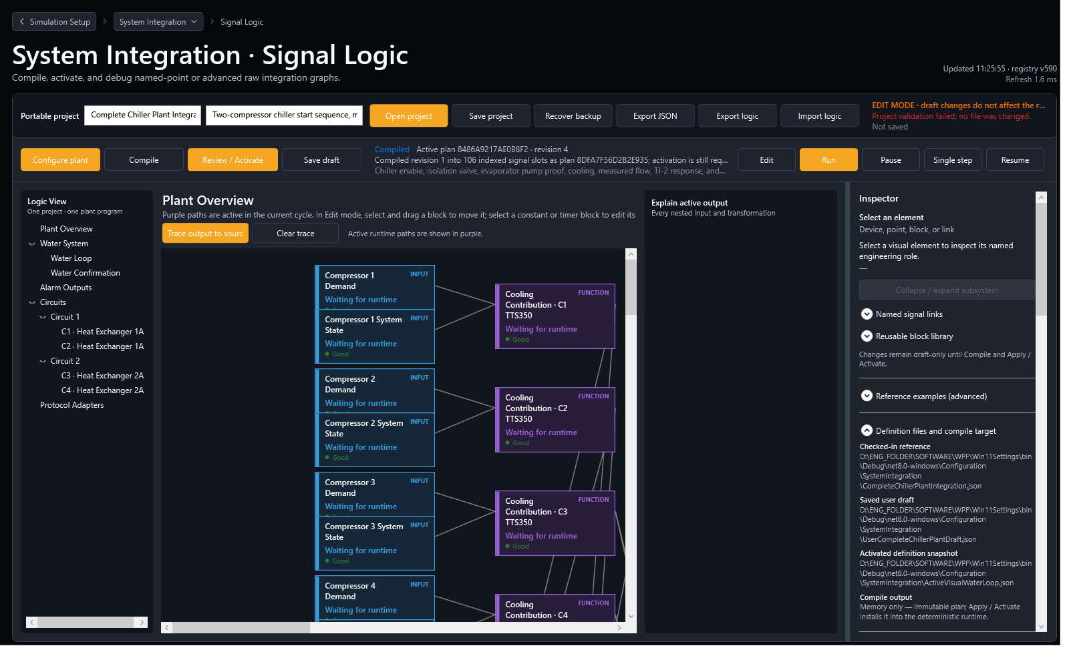
Figure 11. Example 3 validates two circuits, four compressor-specific economizers, and logical roles across two I/O modules.
Compressor | Circuit / economizer | I/O allocation
C1 | Circuit 1 / Heat Exchanger 1A | Stepper AO-1; pressure AI-1; named TI; superheat AI-2
C2 | Circuit 1 / Heat Exchanger 1A | Stepper AO-2; pressure AI-3; named TI; superheat AI-4
C3 | Circuit 2 / Heat Exchanger 2A | Stepper AO-3; pressure AI-5; named TI; superheat AI-6
C4 | Circuit 2 / Heat Exchanger 2A | Stepper AO-4; pressure AI-7; TI-6; superheat AI-8

Item | Reference setting
Portable files | AirCooled_4xTTS350_R515B_2Circuits_4HeatExchangers.modbussim / .modbustest
Water Confirmation | Analog Flow; enable Module 1 DI-1; pump command Module 1 DO-1; flow Module 2 AI-1; ready Module 2 DI-1; TON 5 s
Water design | 1,400 kW full load; 40 kg/s normal flow; 50 kg/s analog full scale; 8 kg/s minimum
Topology checks | C1/C2 contributions feed Circuit 1; C3/C4 feed Circuit 2; all four feed the plant capacity sum and common water loop.
Ownership checks | The second I/O module allows water flow/ready roles without conflicting with eight economizer AI publications on Module 1.

Example 3 test emphasis
- Keep the pump command false and prove analog flow/ready remains false; then command the pump and apply sufficient analog flow for 5 continuous seconds.
- Test each circuit independently, then both together. Confirm no cross-circuit mass-flow or economizer response.
- Verify Unit IDs for both I/O modules before communication and confirm Module 2 AI-1/DI-1 are not mistaken for Module 1 channels.
- Run all four compressors at design load and inspect plant capacity sum, water-loop response, four stepper/superheat lanes, and quality.

Appendix A. Minimal editable TON logic
Text logic remains useful for review and controlled custom modules. The portable .modbussim remains the complete plant handoff.
INPUT "point-solenoid-command" "DO-1 - Interstage Solenoid"
POINT "water-loop-io/points/DigitalOutput1"
END
CONSTANT "constant-proof-delay" "Valve Open Proof Delay"
VALUE 5
UNIT "s"
END
BLOCK "block-valve-proof-delay" "TON - Valve Open Proof"
TYPE "OnDelay"
STATE "ResetOnActivation"
INPUT "Input" FROM "point-solenoid-command" "Value"
INPUT "Delay" FROM "constant-proof-delay" "Value"
END
OUTPUT "output-valve-proof" "DI-4 - Valve Open Proof"
POINT "water-loop-io/points/DigitalInput4"
SOURCE FROM "block-valve-proof-delay" "Value"
END
- Use stable node IDs and explicit point IDs. POSITION changes layout only.
- A timer stores elapsed deterministic simulation time; it resets on activation and whenever Input becomes false.
- Import and Compile validate point access, units, ports, one driver per input, cycles, and output ownership.
- After a custom edit, detach the module from wizard management or a later Apply topology may regenerate the managed copy.

Appendix B. Final acceptance checklist
Complete every item before treating a customer integration as ready for broader testing.
- [ ] Live System count/model/refrigerant/behavior source verified for every compressor.
- [ ] Every connection and Unit ID unique; external communication start order recorded.
- [ ] Every compressor assigned to exactly one circuit and only an installed economizer slot.
- [ ] Every heat-exchanger economizer configured per compressor with unique physical I/O.
- [ ] Water Confirmation mode matches the real plant; optional Pump Enable used only when required.
- [ ] Logical/physical I/O direction, channel, range, unit, normal state, and owner reviewed.
- [ ] Topology applied to draft; custom modules detached before protected edits.
- [ ] Compile passes; revision, fingerprint, signature, and output claims reviewed.
- [ ] Review / Activate passes; previous runtime retention confirmed on a deliberate rejected-draft test.
- [ ] Communications Online; critical point quality Good; manual channel proof complete.
- [ ] Matching .modbustest preflight passes; startup, load, unload, fault/proof-loss, and shutdown checks complete.
- [ ] Control Quality Monitor trends and metrics reviewed; monitor ranges documented as evidence settings.
- [ ] Result/evidence complete and reproducible; deviations recorded.
- [ ] Versioned .modbussim, .bak, .modbustest, report, I/O schedule, versions, signature, and screenshots archived.

Appendix C. Implementation and evidence references
The following checked-in sources and generated evidence support this guide.
- Documentation/SYSTEM_INTEGRATION_REFACTORING_PLAN.md
- Documentation/SYSTEM_INTEGRATION_OPERATOR_GUIDE.md
- Documentation/CONTROL_QUALITY_MONITOR.md
- Documentation/PLANT_TEST_PLANS_AND_EVIDENCE.md
- Configuration/SystemIntegration/Examples/
- Services/SystemIntegrationProjectPackageService.cs
- Services/PlantIntegrationTopologyService.cs
- Services/PlantIntegrationGraphComposer.cs
- Services/PlantControlQualityMonitorService.cs
- Services/SystemIntegrationPhase8ValidationCliService.cs
- Reports/SystemIntegration/Phase8/SystemIntegrationProjectPackageValidation_20260723_Phase7.md
Validation status The Phase 7 regression validates portable round-trip, one-to-eight topology, three identical compressor behavior resolution, module generation, water confirmation, alarm output, per-compressor economizers, multiple I/O modules, protocol adapters, immutable runtime equivalence, fingerprint and revision rejection, active-plan retention, atomic save/backup, legacy migration, Control Quality Monitor, dark-theme rendering, and all three reference projects/test plans.

